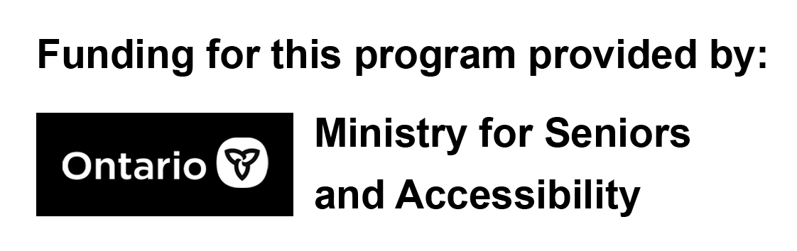

Part 1: COVID-19 Safety

Session Outline:
- Introduction
- Masks & Face Shields
- Hand Washing
- Gloves
- Sanitizer
- Vaccines
- How do you stay safe?

Section 1 – Introduction
Welcome everyone. Facilitator to introduce themselves.
Go over microphones and how the mute and video camera button work.
Brief introduction to the topic.

Section 2 – Masks and Face Shields
Masks: To protect yourself and others, wear a non-medical mask or face covering when:
- You’re in public and you might come into close contact with others
- You’re in shared indoor spaces with people from outside your immediate household
- Advised by your local public health authority
  - https://covid-19.ontario.ca/
Types of Fabrics vs. Disposable Masks
Proper material, structure and fit:
- How well a mask or face covering works depends on the materials used, how the mask is made, and most importantly, how well it fits.
- Disposable masks, also known as single-use masks should only be used once.
- A mask or face covering can be homemade or purchased, and should:
  - Be made of at least 3 layers
    - 2 layers should be tightly woven material fabric; such as cotton or linen
    - The third (middle) layer should be a filter-type fabric, such as a non-woven polypropylene fabric
      - Polypropylene fabric is made directly from material without any need for spinning or weaving
      - It cannot absorb moisture, moisture is instead, passed through the fabric entirely
      - Is typically used in top sheets of diapers, in cold weather gear or sportswear
  - Be large enough to complete and comfortably cover the nose, mouth and chin without gaping
  - Allow for easy breathing
  - Fit securely to the head with ties or ear loops
  - Be comfortable and not require frequent adjustments
  - Be changed as soon as possible if damp or dirty
  - Maintain its shape after washing and drying
- Filters add an extra layer of protection by trapping small infectious particles
How to Wear a Mask
The Dos and DON’Ts
- Use the DOs and DON’Ts on the power point presentation to review the correct way to wear masks

Face Shields
Face shields do not replace masks or face coverings.
- A face shield is used to protect the eyes of the person wearing it. Using a face shield without a mask won’t protect:
  - You from potentially inhaling infectious respiratory droplets exhaled by others
  - Others from your infectious respiratory droplets, as they can escape around the face shield
- If you’re unable to wear a mask or face covering, you may want to wear a face shield. Choose one that extends around the sides of the face and below the chin. You’ll still need to:
  - Maintain physical distancing of 2 metres
  - Practise good hand hygiene, especially if you touch the face shield

Section 4: Gloves
Do I have to wear gloves?
- No. Gloves are not mandatory, nor are they recommended. Hand washing is the number one recommendation by local health authorities to keep hands sanitized.
How many times can I use the same gloves?
- Only once. Gloves should be safely removed and discarded immediately into a garbage bin.
If I do wear gloves, how do I safely remove them?
- Avoid skin contact with any part of the outside of the glove. Follow the steps shown in the visual / graphic

Section 5: Sanitizer
Sanitizer can be used when water and plain soap is unavailable. Must be a minimum of 70% alcohol-based.

Section 6: Vaccine Safety
When it comes to vaccines it’s important to speak with your primary care physician prior to taking the vaccine. With health being your number one concern, your primary care physician can review your health records and help you to decide if you are a suitable candidate.
After the vaccine safety slide, use this information to add on to the slides as needed.
Status:
As of January 15, 2021, at 10:30 a.m. 174, 630 doses have been administered.
Getting the Vaccine implementation plan from the Government of Ontario.
Who will be vaccinated? Taken from https://covid-19.ontario.ca/getting-covid-19-vaccine-ontario#phase-2
Approximately 8.5 million people from the following groups will receive vaccines:
- older adults, beginning with those 80 and older and decreasing in five-year increments over the course of the vaccine rollout
- people who live and work in high-risk congregate settings (for example, shelters, community living)
- frontline essential workers, including first responders, teachers and other education staff and the food processing industry
- individuals with high-risk chronic conditions and their caregivers
- other populations and communities facing barriers related to the determinants of health across Ontario who are at greater COVID-19covid 19 risk
The task force will use the ethical framework and the best available data to identify other priority populations within this phase, based on available vaccine supply.

Everyone should be aware that as the vaccine supply increases, Health care providers will help administer vaccines. This means you will be able to go to your family doctor just like the flu shot.

Tell story about the history of vaccines from the World Health Organization.
In the early 1900s, polio was a worldwide disease, paralysing hundreds of thousands of people every year. By 1950, two effective vaccines against the disease had been developed. But vaccination in some parts of the world was still not common enough to stop the spread of polio, particularly in Africa. In the 1980s, a united worldwide effort to eradicate polio from the planet began. Over many years and several decades, polio vaccination, using routine immunization visits and mass vaccination campaigns, has taken place in all continents. Millions of people, mostly children, have been vaccinated and in August 2020, the African continent was certified wild poliovirus free, joining all other parts of the world except Pakistan and Afghanistan, where polio has not yet been eradicated.

https://www.who.int/news-room/feature-stories/detail/how-do-vaccines-work?utm_source=facebook&utm_medium=landingpageviews&utm_campaign=vaccinebls&fbclid=PAAabA6WQYqpAXTvHNFMMMuVv7ySH0vFo0K6NmfTzPVcrot3JmIBA9GQDq6s0

Section 7 – How have you been staying safe during COVID-19?
Short Open Discussion: Call on participants one at a time and give platform to share with each other the ways they have been staying safe. Encourage them to share anything they are doing that may not have been mentioned throughout the session.

Thank participants for attending the session and let them know that if they are interested in obtaining some resources related to the presentation that they can contact you directly. You can email these resources to them following the session.

Section 8 – Resources
Resources that may be used have been compiled into slides at the end of the presentation for distribution post-session. Slides can be exported into PDFs for convenience and sent to any interested participants or friends and family of participants who have access to internet.

Sanitizer  &  Hand Washing | https://www.toronto.ca/community-people/health-wellness-care/health-programs-advice/hand-hygiene/
Myth Busters | https://www.who.int/emergencies/diseases/novel-coronavirus-2019/advice-for-public/myth-busters?gclid=CjwKCAiAxKv_BRBdEiwAyd40N2XlHyLIl75JRIhxM_FFMznX4uHmTOOb-H7WSxAz8C9-J55T6fPO6hoCBP8QAvD_BwE#breath
Gloves | https://www.publichealthontario.ca/-/media/documents/E/2013/ect-gloves-doffing.pdf?la=en
Masks | https://www.canada.ca/en/public-health/services/diseases/2019-novel-coronavirus-infection/prevention-risks/about-non-medical-masks-face-coverings.html#a1
How to Make Your Own Mask Video Tutorial | https://www.who.int/emergencies/diseases/novel-coronavirus-2019/advice-for-public/when-and-how-to-use-masks
How to Make Your Own Mask Video Tutorial | https://www.canada.ca/content/dam/hc-sc/documents/services/publications/diseases-and-conditions/covid-19-safely-use-non-medical-mask-face-covering/covid-19-safely-use-non-medical-mask-face-covering-en.pdf
Vaccines | https://covid-19.ontario.ca/covid-19-vaccines-ontario
Vaccines | https://www.canada.ca/en/public-health/services/diseases/coronavirus-disease-covid-19/vaccines.html?&utm_campaign=hc-sc-covidvaccine&utm_medium=sem&utm_source=ggl&utm_content=ad-text-en&utm_term=covid%20vaccine%20canada&adv=2021-0051&id_campaign=11503036027&id_source=113997067404&id_content=487727621650  https://www.who.int/news-room/feature-stories/detail/how-do-vaccines-work?utm_source=facebook&utm_medium=landingpageviews&utm_campaign=vaccinebls&fbclid=PAAabA6WQYqpAXTvHNFMMMuVv7ySH0vFo0K6NmfTzPVcrot3JmIBA9GQDq6s0
Created for Rexdale Women’s Centre by Justin Reid

